Analyzing City Hotel Bookings in Portugal (2016)
Data Curation
Name: Raneem Aqel

- Data Sourcing:

- Dataset File Name: hotel_bookings.csv filtered it to create city_hotel_bookings_2016.csv and country_codes.csv.

- Description: Hotel bookings for hotel based in Portugal during 2015-2017, country codes sheet is added in separate sheet manually copied from link in “Variables Description” table mentioned in the source of the dataset.
This is to highlight that the original file contains data for 2 categories of hotels (City & Resort hotel) during 2015-2017, in this project we extracted data related to City hotel bookings during 2016 and all the descriptions below accordingly.

- Dataset Details: city_hotel_bookings_2016: 38,140 rows and 32 columns.
country_codes.csv: 249 row and 5 columns.

- Size: city_hotel_bookings_2016.csv: 16MB. country_codes.csv: 12 KB.

- Source: downloaded as CSV file

- Hotel Bookings Dataset: Kaggle & Science Direct
https://www.kaggle.com/datasets/jessemostipak/hotel-booking-demand https://www.sciencedirect.com/science/article/pii/S2352340918315191#bib6

- Country Codes: International Standards Organization, ISO
https://www.iso.org/obp/ui/#search

- Data Profile:

Important highlights:

- All data below extracted using SQL queries, highlighting 2 fundamental logics while query the data:

- Selected data is restricted where hotel = “city hotel” and arrival_date_year = 2016 without specifying booking cancelation status.
- Selected data is restricted where hotel = “city hotel” and arrival_date_year = 2016 and is_canceled = 1 specifying canceled bookings.

- Below data profiling results is divided into 2 types: Numerical and Categorical data profiling, in each type we are exploring total bookings and canceled bookings.

- Numerical Data Profiling:

- Total Bookings (canceled & confirmed)

Column Name | Count Missing Values | Count  (Rows with values) | SUM | Mean | Median | Mode | Max | Min | Range | STDEV | Other  Observations
hotel | 0 | 38,140 | - | - | - | - | - | - | - | - | each row indicates 1 booking
is_canceled | 0 | 15,407 | - | - | - | - | - | - | - | - | Counting only the canceled bookings
lead_time | 0 | 38,140 | - | 108 | 71 | 0 | 626 | 0 | 626 | 109 | -
stays_in_weekend_  nights | 0 | 38,140 | 29,627 | 0.78 | 1 | 0 | 16 | 0 | 16 | 0.89 | Summing up the total nights  (weekend & weekday)  113,021
stays_in_week_  nights | 0 | 38,140 | 83,394 | 2 | 2 | 2 | 41 | 0 | 41 | 1.50 | Summing up the total nights  (weekend & weekday)  113,021
adults | 0 | 38,140 | 70,568 | - | - | - | - | - | - | - | Summing up the total guests’ number for  all ages 74,577
children | 0 | 38,140 | 3,814 | - | - | - | - | - | - | - | Summing up the total guests’ number for  all ages 74,577
babies | 0 | 38,140 | 195 | - | - | - | - | - | - | - | Summing up the total guests’ number for  all ages 74,577
agent | 3,656 | 34,484 | - | - | - | - | - | - | - | - | Count is for all values except null values
company | 36,297 | 1,843 | - | - | - | - | - | - | - | - | Count is for all values except null values
days_in_waiting_  list | 0 | 38,140 | - | 5 | 0 | 0 | 391 | 0 | 391 | 28.5 | -
adr | 0 | 38,140 | - | 103 | 99 | 75 | 5,400 | 0 | 5,400 | 45 | -

- Total Canceled Bookings

Column Name | Count Missing Values | Count  (Rows with values) | SUM | Mean | Median | Mode | Max | Min | Range | STDEV | Other  Observations
is_canceled | 0 | 15,407 | - | - | - | - | - | - | - | - | -
lead_time | 0 | 15,407 | - | 150 | 113 | 68 | 626 | 0 | 626 | 126 | -
stays_in_weekend_  nights | 0 | 15,407 | 11,578 | 0.75 | 0 | 0 | 9 | 0 | 9 | 0.92 | Summing up the total canceled nights.  Total canceled booked nights  47,199
stays_in_week_  nights | 0 | 15,407 | 35,621 | 2 | 2 | 2 | 22 | 0 | 22 | 1.58
adults | 0 | 15,407 | 28,701 | - | - | - | - | - | -
children | 0 | 15,407 | 1,411 | - | - | - | - | - | - |  | Summing up the total canceled guests’ number for  all ages 30,144
babies | 0 | 15,407 | 32 | - | - | - | - | - | -
agent | 924 | 14,483 | - | - | - | - | - | - | -
company | 15,062 | 345 | - | - | - | - | - | - | - |  | -
days_in_waiting_  list | 0 | 15,407 | - | 9 | 0 | 0 | 391 | 0 | 391 | 34.6 | -
adr | 0 | 15,407 | - | 103 | 99 | 62 | 5,400 | 0 | 5,400 | 54 | -

- Categorical Data Profiling:

- Total Bookings (canceled & confirmed)

Column Name | Count Missing Values | Number of Distinct Values | Example Values | Most Frequent Category
meal | 0 | 4 Distinct | BB, SC, HB, FB | BB 30,343 (79% from total)
country | 0 | 145 Distinct | PRT, FRA, DEU, GBR, ESP | PRT  total bookings 14,031 (36% from total)
market_segment | 0 | 7 Distinct | Online TA, Offline TA/TO, Groups, Direct, Corporate, Complementary, Aviation | Online TA  total bookings 19,708 (51% from total)
distribution_channel | 0 | 4 Distinct | TA/TO, Direct, Corporate, GDS | TA/TO  total bookings 33,155 (86% from total)
reserved_room_type | 0 | 8 Distinct | A, D, F, B, E, G, C, P | A  total bookings 29,652 (77% from total)
deposit_type | 0 | 3 Distinct | No Deposit, Non-Refund, Refundable | No Deposit  total booking 32,227 (84% from total)
customer_type | 0 | 4 Distinct | Transient, Transient-Party, Contract, Group | Transient  total booking 30,298 (79% from total)
reservation_status | 0 | 3 Distinct | Check-Out, Canceled, No-Show | Check-Out  total booking 22,733 (59% from total)

- Total Canceled Bookings

Column Name | Count Missing Values | Number of Distinct Values | Example Values | Most Frequent Category
meal | 0 | 3 Distinct | BB, SC, HB | BB 12,606 (81% from total)
country | 0 | 115 Distinct | PRT, FRA, ESP, GBR | PRT  total bookings 8,798 (57% from total canceled)
market_segment | 0 | 7 Distinct | Online TA, Offline TA/TO, Groups, Direct, Corporate, Complementary, Aviation | Online TA  total bookings 7,149 (46% from total canceled)
distribution_channel | 0 | 4 Distinct | TA/TO, Direct, Corporate, GDS | TA/TO  total bookings 14,461 (93% from total canceled)
reserved_room_type | 0 | 8 Distinct | A, D, F, B, E, G, C, P | A  total bookings 12,475 (81% from total canceled)
deposit_type | 0 | 3 Distinct | No Deposit, Non-Refund, Refundable | No Deposit  total booking 9,518 (61% from total canceled)
customer_type | 0 | 4 Distinct | Transient, Transient-Party, Contract, Group | Transient  total booking 13,608 (88% from total canceled)
reservation_status | 0 | 2 Distinct | Canceled, No-Show | Canceled  total booking 14,852 (96% from total canceled)

- Visualization for Lead time & ADR values:

- Lead time histogram for total hotel bookings:
The histogram is showing that the data is positively skewed with the standard deviation 109 and mean 108, the variables are not concentrated around the mean. The chart is showing that most bookings are booked as last minute (0-11 days)

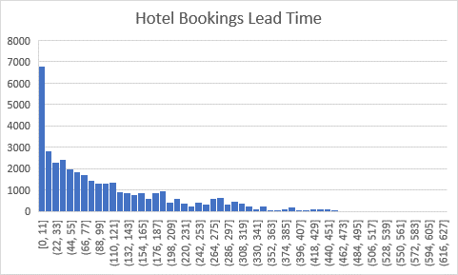

- Lead time histogram for canceled bookings:
The histogram is showing that the cancelation is occurring as last-minute cancelations (cancelation date is near to the arrival date), also the histogram is indicating potential outlier at the end of the tail.

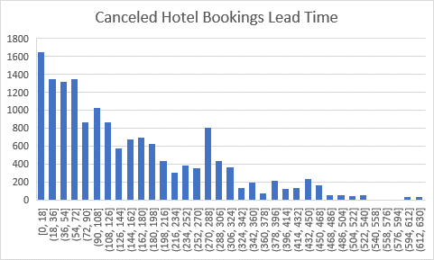

- ADR histogram for total hotel bookings:
histogram is showing distribution of ADR for total hotel bookings is positively skewed, with the majority of values concentrated below approximately 200.
Potential outliers in the end of the tail (5,400)

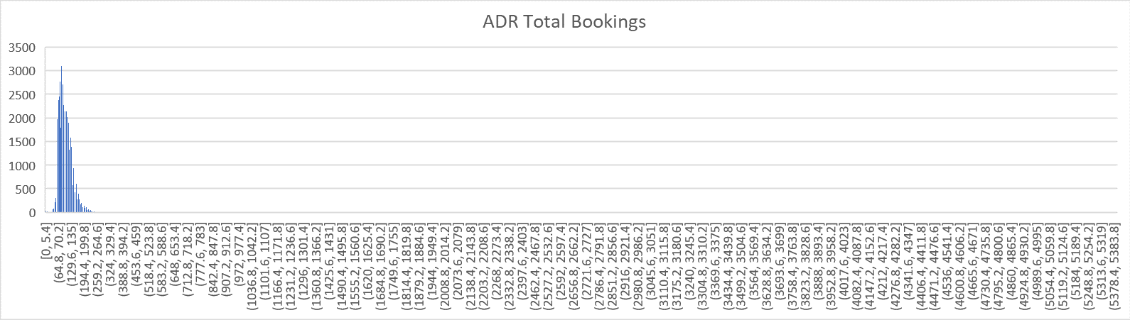

- Data Wrangling:

- Removed agent column: high number of null values.
- Removed company column: high number of null values.
- Removed from ADR outliers i.e., very high number (5400) and very low numbers (0-18), total of 644 row was removed.

- Numerical Data Profiling after data wrangling:

- Total Bookings (canceled & confirmed)
Column Name | Count | SUM | Mean | Median | Mode | Max | Min | Range | STDEV | Other  Observations
hotel | 37,496 | - | - | - | - | - | - | - | - | each row indicates 1 booking
is_canceled | 15,319 | - | - | - | - | - | - | - | - | Counting only the canceled bookings
lead_time | 37,496 | - | 109 | 73 | 0 | 626 | 0 | 626 | 109 | -
stays_in_weekend_nights | 37,496 | 29,305 | 0.78 | 1 | 0 | 9 | 0 | 9 | 0.88 | Summing up the total nights  (weekend & weekday)  111,795
stays_in_week_nights | 37,496 | 82,490 | 2 | 2 | 2 | 25 | 0 | 25 | 1.50 | Summing up the total nights  (weekend & weekday)  111,795
adults | 37,496 | 69,701 | - | - | - | - | - | - | - | Summing up the total guests’ number for  all ages 73,627
children | 37,496 | 3,744 | - | - | - | - | - | - | - | Summing up the total guests’ number for  all ages 73,627
babies | 37,496 | 182 | - | - | - | - | - | - | - | Summing up the total guests’ number for  all ages 73,627
days_in_waiting_list | 37,496 | - | 6 | 0 | 0 | 391 | 0 | 391 | 28.5 | -
adr | 37,496 | - | 105 | 99 | 75 | 452 | 21 | 431 | 34 | -

- Total Canceled Bookings
Column Name | Count | SUM | Mean | Median | Mode | Max | Min | Range | STDEV | Other Observations
hotel | 15,319 | - | - | - | - | - | - | - | - | each row indicates 1 booking
is_canceled | 15,319 | 15,319 | - | - | - | - | - | - | - | Counting only the canceled bookings
lead_time | 15,319 | - | 150 | 626 | 68 | 626 | 0 | 626 | 126 | -
stays_in_weekend_nights | 15,319 | 11,521 | 0.75 | 0 | 0 | 9 | 0 | 9 | 0.92 | Summing up the total nights  (weekend & weekday)  46,994
stays_in_week_nights | 15,319 | 35,473 | 2.3 | 2 | 2 | 22 | 0 | 22 | 1.6 | Summing up the total nights  (weekend & weekday)  46,994
adults | 15,319 | 28,590 | - | - | - | - | - | - |  | Summing up the total guests’ number for  all ages  30,018
children | 15,319 | 1,396 | - | - | - | - | - | - |  | Summing up the total guests’ number for  all ages  30,018
babies | 15,319 | 32 | - | - | - | - | - | - |  | Summing up the total guests’ number for  all ages  30,018
days_in_waiting_list | 15,319 | - | 9 | 0 | 0 | 391 | 0 | 391 | 34.6 | -
adr | 15,319 | - | 102 | 99 | 62 | 306 | 26 | 280 | 32 | -

- Categorical Data Profiling:

- Total Bookings (canceled & confirmed)

Column Name | Number of Distinct Values | Example Values | Value Counts (Top categories)
meal | 4 Distinct | BB, SC, HB, FB | BB  29,847 (79% from total)
country | 145 Distinct | PRT, FRA, DEU, GBR, ESP | PRT  total bookings  13,534 (36% from total)
market_segment | 7 Distinct | Online TA, Offline TA/TO, Groups, Direct, Corporate, Complementary, Aviation | Online TA  total bookings  19,579 (52% from total)
distribution_channel | 4 Distinct | TA/TO, Direct, Corporate, GDS | TA/TO  total bookings  32,839 (87% from total)
reserved_room_type | 7 Distinct | A, D, F, B, E, G, C | A  total bookings  29,192 (77% from total)
deposit_type | 3 Distinct | No Deposit, Non Refund, Refundable | No Deposit  total booking  31,587 (84% from total)
customer_type | 4 Distinct | Transient, Transient-Party, Contract, Group | Transient  total booking  29,798 (79% from total)
reservation_status | 3 Distinct | Check-Out, Canceled, No-Show | Check-Out  total booking  22,177 (59% from total)

- Total Canceled Bookings
Column Name | Number of Distinct Values | Example Values | Value Counts (Top categories)
meal | 3 Distinct | BB, SC, HB | BB  12,539
country | 113 Distinct | PRT, FRA, ESP, GBR | PRT  total bookings  8,727 (56% from total)
market_segment | 6 Distinct | Online TA, Offline TA/TO, Groups, Direct, Corporate, Aviation | Online TA  total bookings  7,131(46% from total)
distribution_channel | 4 Distinct | TA/TO, Direct, Corporate, GDS | TA/TO  total bookings  14,412 (94% from total)
reserved_room_type | 7 Distinct | A, D, F, B, E, G, C | A  total bookings  12,414 (81% from total)
deposit_type | 3 Distinct | No Deposit, Non-Refund, Refundable | No Deposit  total booking  9,434 (61% from total)
customer_type | 4 Distinct | Transient, Transient-Party, Contract, Group | Transient  total booking  13,538 (88% from total)
reservation_status | 2 Distinct | Canceled, No-Show | Canceled  total booking  14,775 (96% from total)

- Visualization for ADR values after cleaning:

- ADR histogram for total hotel bookings:
The ADR histogram after cleaning shows a more concentrated and approximately normal distribution compared to the original histogram

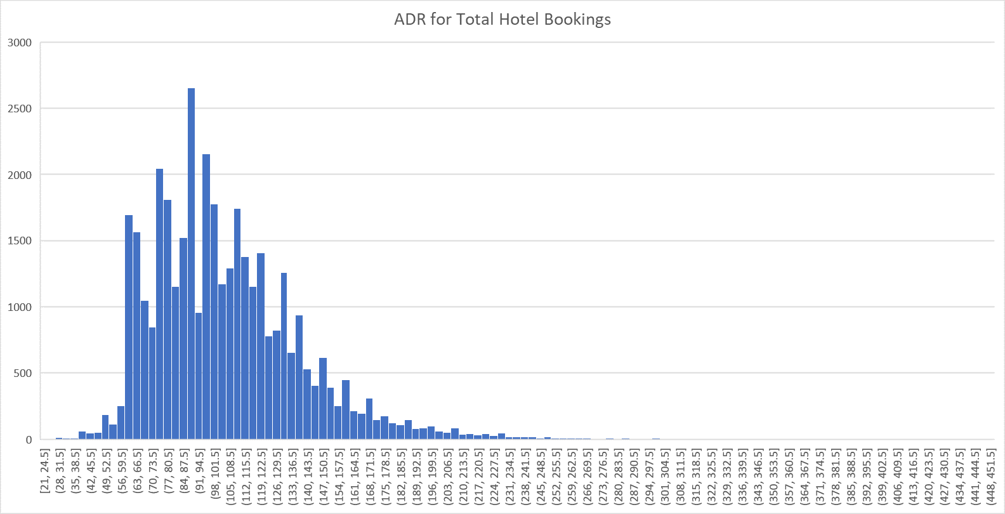

Data Table Schema:

Field | Type | Description
hotel | CATEGORICAL - STRING | Hotel category
is_canceled | BOOLEAN | Indicating if the booking is canceled or not
lead_time | NUMERICAL- INTEGER | Days between the date of creating the booking and arrival date (advanced booking days)
arrival_date_year | NUMERICAL- INTEGER | Year of arrival
arrival_date_month | DATETIME | Month of arrival
arrival_date_week_number | NUMERICAL- INTEGER | Week number arrival date
arrival_date_day_of_month | NUMERICAL- INTEGER | month's day of arrival
stays_in_weekend_nights | NUMERICAL- INTEGER | Days stayed during weekend nights
stays_in_week_nights | NUMERICAL- INTEGER | Days stayed during week nights
adults | NUMERICAL- INTEGER | Number of adult guests
children | NUMERICAL- INTEGER | Number of children guests
babies | NUMERICAL- INTEGER | Number of babies guests
meal | CATEGORICAL - STRING | Type of meal
country | CATEGORICAL - STRING | Origin country code
market_segment | CATEGORICAL - STRING | Market segment designation
distribution_channel | CATEGORICAL - STRING | Channel booking created
is_repeated_guest | BOOLEAN | If the guest is frequent customer
previous_cancellations | NUMERICAL- INTEGER | Number of canceled bookings before the current booking
previous_bookings_not_canceled | NUMERICAL- INTEGER | Number of uncanceled bookings before the current booking
reserved_room_type | CATEGORICAL - STRING | Room code on the booking
assigned_room_type | CATEGORICAL - STRING | Room code granted upon arrival
booking_changes | NUMERICAL- INTEGER | Number of changes/amendments made to the booking from booking creation to check-in or cancellation
deposit_type | CATEGORICAL - STRING | Deposit category made on the booking
agent | NUMERICAL- INTEGER | Travel agent ID
company | NUMERICAL- INTEGER | Company ID
days_in_waiting_list | NUMERICAL- INTEGER | Number of days the booking stayed on waitlist before confirmation
customer_type | CATEGORICAL - STRING | Type of customer category
adr | NUMERICAL- FLOAT | Average Daily Rate, calculated by dividing the sum of all lodging transactions by the total number of staying nights
required_car_parking_spaces | NUMERICAL- INTEGER | Number of parking spaces required on the booking
total_of_special_requests | NUMERICAL- INTEGER | Number of special requests made
reservation_status | CATEGORICAL - STRING | Reservation last status
reservation_status_date | DATETIME | Date of last reservation status

